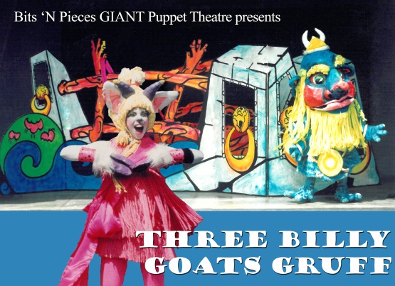
Bits N Pieces Puppet Theatre
12904 Tom Gallagher Road Dover, FL 33527 813-659-0659 jerry@puppetworld.com

Thank you for presenting our original musical adaptation, Three Billy Goats Gruff. To help you make your event successful, we’ve prepared the following media releases and program information. Please use them anywhere and anytime you promote our program. Just like our GIANT puppets, we want your event to be a HUGE success.

This packet contains two sample media releases (one standard length and one abbreviated version), background information on the company and performers, and a sample flyer suitable for photocopying. How to use these:

Using your own letterhead, simply copy our text and fill in the highlighted blanks. Send to your local newspapers, magazines, and televisions stations.

Use the abbreviated version to send to the attention of the Events/ Calendar Editor at your local media. You can also adapt this version to create flyers for distribution to schools and daycare centers.

Use flyer page as a Word document to type in your information and print via your printer or copy machine. It’s an easy, inexpensive flyer you can distribute quickly.

PHOTOGRAPHY
Color jpg photographs and line art are available for the show. Tif format is available upon request.

STUDY GUIDES

Our study guides are a tremendous asset to sponsors and their education partners. Use them early when promoting ticket sales and provide them to teachers prior to attending performances as an aid to lesson planning. Highly rated by teachers across the nation, Bits ‘N Pieces education resource guides provide pre-performance discussion topics, story background, lesson activities and are the perfect post-performance complement to helping children develop their appreciation for the arts.

Guides may be obtained from our website, www.PuppetWorld.com or by calling Bits ‘N Pieces Puppet Theatre at (813) 659-0659.

On with the show!

Jerry Bickel, Director, Bits ‘N Pieces Puppet Theatre

FOR IMMEDIATE RELEASE
For more information, contact <insert your organization’s name, contact person, phone number>

Avoid Billy-Ache with Laughter!

The <place of performance> presents “Three Billy Goats Gruff” a lively and colorful musical production for young audiences featuring the nine-foot-tall body puppets and a host of other characters from the internationally acclaimed Bits ‘N Pieces Puppet Theatre.
It is up to Bluff, Fluff and Tuff Gruff, the three goats, to cleverly cross a narrow bridge. “Trip, trap, trip, trap,” the goat’s feet go as they try to sneak across the bridge. “Who dares to cross my Bridge?,” asks Upchuk the Bully Troll. He wants no one to cross the bridge. Bluff, Fluff and Tuff must cooperate, communicate and negotiate to eat a dinner of fresh tasty green grass on the other side of the bridge.
Children will be delighted by the glo-in-the-dark puppets as they sing and dance and live happy ever after. Bluff Gruff, the innocent goat, uses his brains to cross the bridge. Fluff Gruff, played by live actress Holli Rubin, points out the fine points of avoiding a bully. Tuff Gruff shows that sometimes actions speak louder than words. Together they prove there’s nothing you can’t do.
The show, which took nearly two years to construct, is filled beautiful puppets and fun. The beloved Norwegian folk tale is one of eleven original musical productions created by Bits ‘N Pieces Puppet Theatre based in Tampa, Florida. Bits ‘N Pieces is known especially for its giant body puppets who have danced across U.S. stages for 37 years and made 16 international appearances, most recently at the 9th International Puppet Festival of Puppet Arts in the Czech Republic.
“Three Billy Goats Gruff” is presented locally by <your organization’s name>. Performances are <date> at <time> at <place of performance>. Tickets are $<price> and are available by calling <your telephone>.

Bits 'N Pieces is sponsored by the Arts Council of Hillsborough County, Hillsborough County Board of County Commissioners, Florida Division of Cultural Affairs, Florida Arts and Humanities Council, and the National Endowment for the Arts.
###
Photo opportunities and interviews are available to media organizations. Please call <your organization, telephone and/or email information>. Digital photos and art are also available.

MEDIA RELEASE
Contact: <insert your name, phone number>
Photos and photo opportunities available.

Three Billy’s cross the bridge three ways
<Your Organization’s Name> Presents Three Billy Goats Gruff
Nine-foot-tall giant glo-in-the-dark puppets dominate the stage in the classic Three Billy Goats Gruff at <insert your facility name>. Children will delight in the lively musical action with these larger-than-life puppets performed by the internationally acclaimed Bits ‘N Pieces Puppet Theatre. This toe-tapping musical production features towering nine-foot-tall dancing puppets, live actress Holli Rubin, and a host of other singing and dancing characters.

It is up to Bluff, Fluff and Tuff Gruff, the three goats, to cleverly cross a narrow bridge. “Trip, trap, trip, trap,” the goat’s feet go as they try to sneak across the bridge. “Who dares to cross my Bridge?,” asks Upchuk the Bully Troll. He wants no one to cross the bridge. Bluff, Fluff and Tuff must cooperate, communicate and negotiate to eat a dinner of fresh tasty green grass on the other side of the bridge.

SHOW: Three Billy Goats Gruff
EVENT DATES: <insert your performance dates>
LOCATION: <insert your address and/or directions>
TICKETS: <insert your ticket cost and/or phone number>

RESERVATIONS: <insert your phone number>

# # #

THEATER HISTORY

About Bits ‘N Pieces Theatre
America’s Giant Puppet Company

Specializing in musicals featuring the art of puppetry, Bits ‘N Pieces Theatre produces original adaptations of classic children’s literature. Their productions have been seen by millions of children in the United States, Asia, and Europe.

The company was founded in 1973 in Tampa, Florida by Jerry Bickel, who continues today as Executive Director. Jerry met Holli at a National Puppetry Festival while presenting “Beowulf”. They created a dozen shows with traditional puppets. They created their giant body puppets for historic Tampa Theatre which immediately became the company’s unique style. Located just outside of Tampa, Florida, Bits ‘N Pieces Theatre now includes PuppetWorld Playhouse, a studio workshop, and exhibition space.

Since 1988 Bits ‘N Pieces has conducted international exchange programs taking their performances to Singapore, Hong Kong, Japan, Taiwan, Trinidad, Guatemala, Germany and the Czech Republic. They also sponsored visits to the USA by artists from those countries as well as the Soviet Union and China. The artistic beauty and craftsmanship of the giant puppets has been exhibited in a 4,000 square foot tribute at the Evansville (IN) Museum of Arts and Science, at the Munich (Germany) Kinder Museum, and in libraries and museums across the United States.

Beginning in 2012 the company began experimenting with shadow puppetry, projections, and video. The integration of live and projected characters and settings have permitted the company to take their giant puppets to new worlds and artistry to new places. Media accompaniment has been created for five productions including “Aesop’s Dinosaur Fable”, “Three Billy Goats Gruff” and “Alice in Wonderland”. In 2019 Bits ‘N Pieces will premiere their new edition of “The Musical Tale of Peter Rabbit”.

Bits 'N Pieces is sponsored by the Arts Council of Hillsborough County, Hillsborough County Board of County Commissioners, Florida Division of Cultural Affairs, Florida Arts and Humanities Council, and the National Endowment for the Arts.

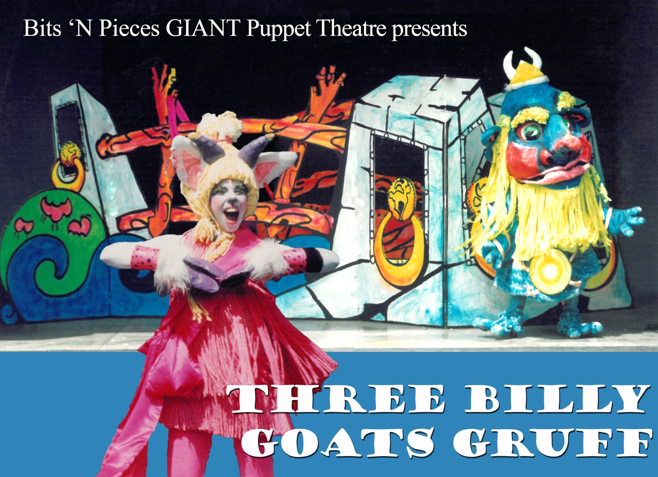

See the Glo-In-the-Dark
Nine foot tall Giants of
Bits ‘N Pieces Puppet Theatre!

<Who, What, When, Where, How Much
Paste your performance information here.>

It’s a HUGE Show filled with Singing, Dancing, Laughter,
and Enormous Fun for Everyone!

